Microsoft Access Trust Center
Often installation problems are caused by the systems security settings. Case in point Microsoft Access trust center settings. These hints are for systems using Office 2010.
In Access, click File/Options/Trust Center/Trust Center Settings.
The first item to check is the trusted locations. Ensure that the location of VPro is in a trusted location.
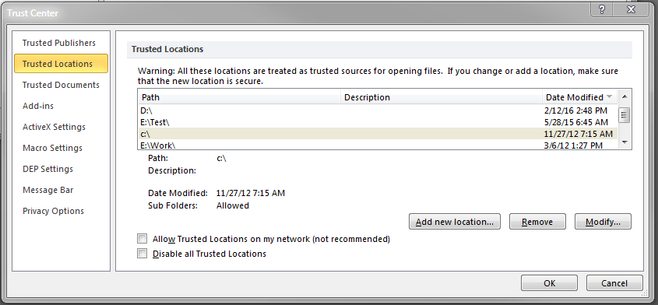
And that you are also trusting subfolders of that location
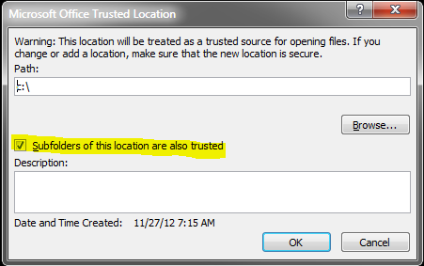

VPro does use some macros so you need to enable them
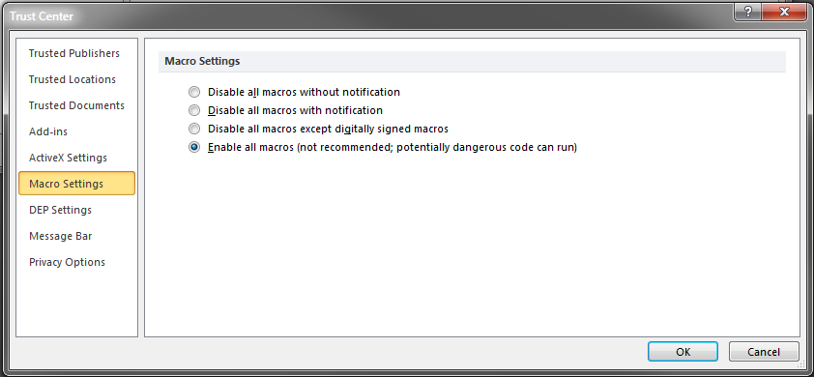
The following settings should be sufficient for VPro’s use of Active X controls.
